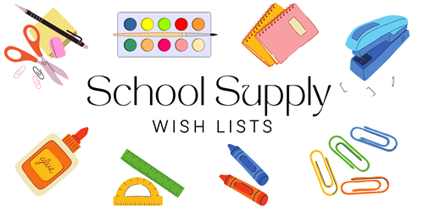

**4TH GRADE – DUAL LANGUAGE ONLY**

**24/25**

48 #2 TIONDEROGA PENCILS (SHARPENED)

5 ELMER GLUE STICKS (LARGE)

2 REAMS OF COPY PAPER

1 BOX OF CRAYOLA COLORED PENCILS (24ct)

1 BOX OF CRAYOLA MARKERS (8ct)

1 PAIR OF HEADPHONES OR EARBUDS

1 BOX OF TISSUES (GIRLS)

4 MAGIC ERASERS (GIRLS)

1 BOX QUART SIZE ZIPLOCK BAGS (GIRLS)

1 BOX GALLON SIZE ZIPLOCK BAGS (BOYS)

1 PACKAGE OF POST-IT NOTES – 3x3 (BOYS)

1 CONTAINER OF CLOROX WIPES (BOYS)

1 MUSICAL RECORDS FOR MUSIC CLASS

1 WHITE 2” BINDER (3 RINGS)

6 3 HOLED POCKET FOLDER (2 RED, 2 GREEN & 2 BLUE)

6 PACKS WIDE RULE COMPOSITION NOTEBOOKS (ANY COLORS)

2 PACKS WIDE RULED LINED PAPER

1 PACK INDEX CARDS (3x5)

2 PACKS SHEET PROTECTORS

1 PACK LARGE ERASERS

4 HIGHLIGHTERS (ANY COLORS)

1 PAIR 5” FISKAR SCISSORS

4 BLACK EXPO WHITEBOARD MARKERS

1 PENCIL CASE (STUDENT’S CHOICE)

2 LANYARDS WITH ID HOLDER

2 FINE TIP SHARPIES (BLACK)